SPANISH UNIT OF STUDY CHOICE BOARD
It’s your opportunity to pick the units of study you want to pursue! On these pages you will find 10 different units of study (each different row). For each week until the end of our school year you should earn 3 points. Check out the point values above each different unit of study. Can you mix and match units within the same week? That is fine. Have fun with this! Find the tasks you’ll enjoy doing. I have ELIMINATED the need for you to turn in PAPER to the school. At the end of each task you will see how to PROVE you did the task. At the top of each task you’ll see (* or ?). The asterisk means you should be able to do this task without internet access. The question mark means you might, depending on your home circumstance. No mark means you will need internet for that task.

If you don’t have access to a phone with a camera in it or you have impossible phone service at home, you may choose the paper assignments and submit them when we return to school.
Easy - 1 point | Medium - 2 points | Medium - 2 points | Medium - 2 points | Hard - 3 points
LA CASA*  Label 10 items around your house in Spanish (ex. Stove, fridge, mirror, etc.). Use a sheet of paper, index card, whatever works! Leave the labels up for the week...or at least a few days.  PROOF: Take a picture of all 10 or your “labels” in one picture and another picture with you IN the picture with at least one “label”. SEND YOUR PICS TO ME THROUGH EMAIL. | LA CASA*  Draw a floor plan of your house. Like this...  Label all the rooms in Spanish and put at least 2 pieces of furniture (labeled in Spanish) in EACH room.  PROOF: 2 photos - a close up of your floor plan...so I can read your labels AND a photo of you holding your floor plan.  SEND YOUR PICS BY EMAIL. | LA CASA*  Write a paragraph about your house (at least 5 sentences). Include who you live with (Vivo con..) (Esta en… is located in)(tiene… it has) Check out this example...  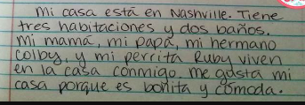  PROOF: Your paragraph must be handwritten by you. Take a photo of your writing so that I can read it and SEND YOUR PICS BY EMAIL. | LA CASA  Watch this video Top 5 SuperLatina: Las Mansiones de los Famosos  It quickly tours the homes of Mariah Carey, formerly married couple J.Lo and Marc Anthony, Christina Aguilera, Salma Hayek, and Ricky Martin. While watching take notes for these two categories.  *List in Spanish a total of 3 facts you learned while watching...rewatch if needed.  *Write a SPANISH sentence about the home you prefer and why. (Prefiero...porque….)  This may be typed or handwritten and  SEND YOUR PICS BY EMAIL. | LA CASA ?  Video yourself walking around your home explaining the new words you have learned in Spanish about your home. Think rooms, furniture, colors,...what else can you say. Your narration will be in Spanglish...it’s ok! At least you’re trying!! Keep your video short… between 20 to 30 seconds. The shorter it is the more Spanish I need to hear. SEND YOUR VIDEO BY EMAIL.
Easy - 1 point | Medium - 2 points | Medium - 2 points | Medium - 2 points | Hard - 3 points
LA FAMILIA*  Draw out your family tree labeling each person with their name and their position in the family (ex. la madre)  PROOF: 2 photos - a close up of your family tree...so I can read your labels AND a photo of you holding your family tree.  SEND YOUR PICS BY EMAIL. | LA FAMILIA*  Think of one of your favorite TV shows or movies that has a family in it. Draw and label in Spanish the family tree for that family.  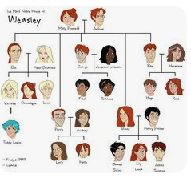  PROOF: 2 photos - a close up of the family tree...so I can read your labels AND a photo of you holding the family tree.  SEND YOUR PICS BY EMAIL. | LA FAMILIA*  Write 5 sentences in Spanish to respond to one of these prompts.  *¿Cuántos miembros hay en tu familia? ¿Quiénes son?  *Describe a tus padres. ¿Son amables, serios, muy estrictos, etc?  *¿Quién es la persona más joven (young) y más vieja (old) en tu familia?  PROOF: Your paragraph must be handwritten by you. Take a photo of your writing so that I can read it and SEND YOUR PICS BY EMAIL. | LA FAMILIA  Watch this video  Learn Spanish Vocabulary - Speak about your family in Spanish  After a brief intro to review family terms, the video takes you to the streets to listen to 6 different people describe their family. Record one specific fact SENTENCE in English about at least 5 of the 6 real people who talk.  This may be typed or handwritten and  SEND YOUR WRITING BY EMAIL. | LA FAMILIA ?  Video yourself describing your family or a family from your favorite TV show or movie. This should be completely in Spanish. (Es...is) (Tiene...has) (Vive...lives) Your video should be between 15-30 seconds long. Shorter videos for Span. I and longer for Span. 4.  SEND YOUR VIDEO BY EMAIL.
Easy - 1 point | Medium - 2 points | Medium - 2 points | Medium - 2 points | Hard - 3 points
EL TIEMPO*  On a sheet of paper draw 4 scenes to represent the four seasons (la primavera - spring / el verano - summer / el otoño - fall / el invierno - winter). Label the seasons in Spanish.  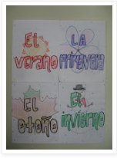  PROOF: send me a selfie of you with your artwork.. SEND YOUR PICS BY EMAIL. | EL TIEMPO*  Add to the seasons drawings or start here with this box… Add the normal weather conditions and be sure to represent them visually and labeled in Spanish.  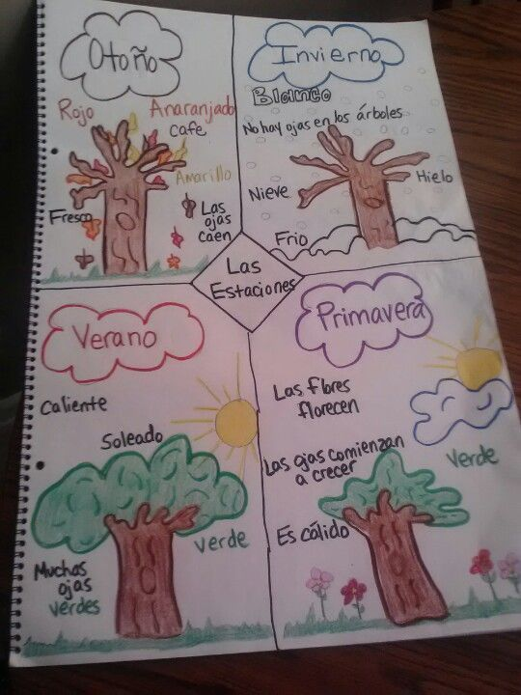  PROOF: send me a selfie of you with your artwork.. SEND YOUR PICS BY EMAIL. | EL TIEMPO*  Keep a log of the weather for the week. Write 5 sentences similar to this… El lunes hace viento.  (los días - lunes, martes, miércoles, jueves, sábado, domingo)  PROOF: Your paragraph must be handwritten by you. Take a photo of your writing so that I can read it and SEND YOUR PIC TO YOUR CLASS’ BY EMAIL. | EL TIEMPO  Watch this video and figure out the answer to this question:  What is the high temperature for Monday?  Click here for the link...El pronóstico del tiempo: regresa la lluvia  SEND YOUR ANSWER BY EMAIL Sra. (Don’t just send me a number. Put some info with it so I know why you’re sending me a number :) | EL TIEMPO ?  Video yourself describing the weather over the past several days. Your video will be completely in Spanish. It should be between 15-30 seconds long.  SEND YOUR VIDEO BY EMAIL.
Easy - 1 point | Medium - 2 points | Medium - 2 points | Medium - 2 points | Hard - 3 points
AROUND THE HOUSE*  Make a chart of at least 6 different colors in Spanish. Then, under each color, make a list of items you see or find around/inside your home that are those colors. Here’s the thing… try to list those items in Spanish. You might not know the words for all of those items. You must have at least 18 items in total on your list. At least 10 of those items need to be in Spanish.  PROOF: SEND YOUR TYPED OR HANDWRITTEN LIST, SEND YOUR PICS BY EMAIL. | AROUND THE HOUSE*  Draw a scene from a TV show, movie, or video game that you are very familiar with. Add a two sentence description of the scene using structures equivalent to your Spanish level (Spanish 1 sentences will be simpler than Spanish 4 sentences). This will all be done by your hand. PROOF: 2 photos - a close up of your scene...so I can read your sentences AND a photo of you holding your scene. SEND YOUR PICS BY EMAIL. | AROUND THE HOUSE ?  Text a friend or family member who is also taking Spanish, has taken Spanish, or speaks Spanish fluently using only Spanish. Your texts back and forth should fill at least two screenshots. Share those screenshots with me.  SEND YOUR PICS BY EMAIL. | AROUND THE HOUSE ?  Card Games: Play Mano Nerviosa or Noventa y Nueve in Spanish with someone you live with or play it virtually with a friend. Use these links to help you to play.  Mano Nerviosa  or  Video Tutorial #6: Noventa y Nueve  PROOF: SEND A SELFIE/GROUPIE PHOTO OF YOU AND FAMILY PLAYING BY EMAIL. | AROUND THE HOUSE*  Pick a DVD that you have watched several times or stream a movie that you have seen several times. Watch it with the Spanish language track instead of in English for at least 30 minutes. Record 10 Spanish words that are common to the movie and their translation to English. PROOF: Your list may be handwritten or typed. SEND YOUR WRITING BY EMAIL
Easy - 1 point | Medium - 2 points | Medium - 2 points | Medium - 2 points | Hard - 3 points
SOY YO*  Send me a selfie! That’s it. Why? Because I miss you:)  SEND YOUR PIC BY EMAIL. | SOY YO*  Draw a picture/mural of life as you know it now. Lace into your drawing 10 words (individual words, in phrases, or a sentence) in Spanish that help your picture. Your choice. Your work must make sense and go together. Put effort into this...this is not a quickie stick figure, pencil only kind of work. Though stick figures will work. I’m just saying, try more than a kid just trying to mark a box off his to do list.  PROOF: send me a selfie of you with y our artwork. SEND YOUR PICS BY EMAIL | SOY Yo?  Create a Snapchat that represents you and your time at home over these last weeks. Use props, filters, etc. It MUST include a sentence in Spanish of your choice that goes with the visual you are creating. You have a lot of freedom with this. Make sure it’s appropriate though.  SEND YOUR SAVED PIC BY EMAIL. | SOY YO  Watch this video.  You Tube link to Soy Yo music video  Soy Yo has always been a favorite. But, Bomba Estereo has so many other great songs. Check out some other videos by Bomba Estero. In English tell me what other songs you listened to? Which was your favorite? Why? This may be typed or handwritten and  SEND YOUR WRITING BY EMAIL. | SOY YO?  Video yourself describing a show or movie you’ve watched since we’ve been out of school. Describe the characters and what happened if you can. Your narration will be in Spanglish...it’s ok! At least you’re trying!! Keep your video short… between 20 to 30 seconds. The shorter it is the more Spanish I need to hear. SEND YOUR VIDEO BY EMAIL.
Easy - 1 point | Medium - 2 points | Medium - 2 points | Medium - 2 points | Hard - 3 points
CON TU FAMILIA*  Teach 8 Spanish words to someone you live with. They must be connected to each other...like 8 adjectives, or foods, or people words.  PROOF: SEND YOUR LIST OF WORDS AND WHO YOU TAUGHT BY EMAIL. | CON TU FAMILIA*  Head outside with your family...ONLY IF OK WITH YOUR GROWN-UPS and IF YOU HAVE THE SPACE TO MAINTAIN DISTANCE!! Play a yard game of futbol (soccer)! Or, basquetbol (some popularity in Spain),or beisbol (super popular in Cuba, Dominican Republic, and Puerto Rico) PROOF: SEND A GROUP PHOTO OF YOU AND YOUR FAMILY AT PLAY BY EMAIL. | CON TU FAMILIA  Share some songs we’ve done in Spanish class or some of our Wooly songs with a family member. What do he/she think of them? Has he/she seen anything like it before?  PROOF: SEND YOUR SONG LIST AND WHO YOU SHARED WITH BY EMAIL. | CON TU FAMILIA  Pick a Zumba video from this link ...  Dance and Zumba Videos in Spanish for Kids to Adults  Get your dance on alone or with some family! Your little siblings would love some attention probably! On the link you’ll find MANY video choices. If you scroll about ½ way down the page you’ll start to see older choices with songs you’ve heard in Spanish class. PROOF: SEND A SELFIE/GROUPIE PHOTO OF YOU AND YOUR FAMILY ENJOYING THE ZUMBA BY EMAIL. | CON TU FAMILIA*  Prepare a meal for your family or with the help of your family in the style of a Spanish-speaking country. Tex-Mex food will do. And then, Buen Provecho! Enjoy! PROOF: SEND A GROUPIE PHOTO OF YOU AND YOUR FAMILY ENJOYING THE MEAL BY EMAIL.
Easy - 1 point | Medium - 2 points | Medium - 2 points | Medium - 2 points | Hard - 3 points
EL MUNDO  Find a rock outside suitable for painting. Remember to keep your distance from others. Choose a flag from a Spanish-speaking country and paint it onto that rock.  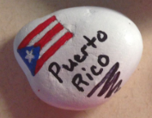  PROOF: SEND A PHOTO OF YOU HOLDING THE ROCK BY EMAIL. | EL MUNDO  Research a legend from a Spanish-speaking country (ex. El Cucuy, La Chupacabra, El Silbon, La Llorona, there are soooooo many to choose from). Draw a picture or build a sculpture of the legendary creature.  PROOF: SEND A PHOTO OF YOUR MASTERPIECE AND INCLUDE THE NAME OF THE LEGEND BY EMAIL. | EL MUNDO  Choose a well-known person from a Spanish-speaking country. Research him/her. Prepare a 10 sentence write-up about your person in ENGLISH. PROOF: Your paragraph can be handwritten by you or typed. Take a photo of your writing so that I can read it and SEND YOUR PIC BY EMAIL or email your typed research. | EL MUNDO  Watch this video about Cinco de mayo…  And prepare a list of 5 facts in ENGLISH that you learned from the video. This may be typed or handwritten and  SEND YOUR WRITING BY EMAIL. | EL MUNDO  Pick a Spanish-speaking country and prepare a MINI poster of info about your country. Include at least 10 factoids. Make your MINI poster attractive and eye catching. PROOF: 2 photos - a close up of the poster...so I can read your facts and see your amazing work AND a photo of you holding your poster. SEND YOUR PICS BY EMAIL.
Easy - 1 point | Medium - 2 points | Medium - 2 points | Medium - 2 points | Hard - 3 points
ONLINE RANDOM  Use this link (Lyrics Training) to play with some of the songs from our Locura bracket or any Spanish song :)  Learn Spanish for Free with Music Videos, Lyrics and Karaoke!  Go to Web, Choose Spanish Language, and then search the song you want to work with. Once you pick your song: choose your level, then pick “Choice Mode”, and when it pops up to sign up, click “Maybe Later”. Practice with 3-4 of your favorite songs from our bracket.  PROOF: SEND A LIST OF THE SONGS YOU WORKED WITH BY EMAIL. | ONLINE RANDOM  Watch two episodes of the Buena Gente series. Use this link...  You Tube link to Buena Gente series to get to the full playlist. In English describe what happened in the episode you watched. This may be typed or handwritten and  SEND YOUR WRITING BY EMAIL. | ONLINE RANDOM  Play on the DuoLingo app for 15 minutes. Duolingo - The world's best way to learn a language  This can be added as an app to your phone or played on your computer. There are fun activities and stories to mess around with. It’s a fun app to mess around in when you have extra time...and we have a lot of that now! PROOF: SEND A SCREENSHOT OR PIC OF YOUR XP FOR THE DAY BY EMAIL. | ONLINE RANDOM  Play on the DuoLingo app for 15 minutes. Duolingo - The world's best way to learn a language  This can be added as an app to your phone or played on your computer. There are fun activities and stories to mess around with. It’s a fun app to mess around in when you have extra time...and we have a lot of that now! PROOF: SEND A SCREENSHOT OR PIC OF YOUR XP FOR THE DAY BY EMAIL. | ONLINE RANDOM  Watch a movie or an episode of a Spanish show on Netflix:  (Examples:Always a Witch  Go! Vive a tu manera  High Seas  Velvet  Morocco in Times of War  Grand Hotel)  Make sure to watch with the language track in Spanish. You can put the subtitles in English.  PROOF: Write a review of the show. What show did you watch? Who were its main characters? What did you think of them? What was the problem in the episode? What do you expect to happen in future episodes?  This may be typed or handwritten and  SEND YOUR WRITING BY EMAIL.
Easy - 1 point | Medium - 2 points | Medium - 2 points | Medium - 2 points | Hard - 3 points
WOOLY  Do one Wooly Nugget of your choice.  SEND AN EMAIL.SO I KNOW WHAT SONG AND NUGGET YOU DID. | WOOLY  Complete 2 Wooly Nuggets (this is on top of the previous box’s option to do one… so if you do this box and the previous, you’d be doing 3 Nuggets).  SEND AN EMAIL SO I KNOW WHAT SONG AND NUGGET YOU DID. | WOOLY  Play in La Rocola for 2-3 or more songs… at least 14 minutes. (Remember this game is located in the menu...the little lines in the top corner of your Wooly homepage.)  SEND A LIST OF THE SONGS PLAYED BY EMAIL. | WOOLY?  Use your favorite Wooly lines to caption 8 pictures you take at home. Make this product in any of your photo editing apps and/or on POWERPOINT and SEND BY EMAIL. | WOOLY  Video yourself lip syncing to your Wooly song of choice. Or really singing if you want. Here’s the important part… you must include movements and/or props throughout the recording that go with the song’s lyrics throughout your performance. You only need to record 30 seconds unless you are certain you know how to send a larger video file. SEND YOUR VIDEO BY EMAIL.

